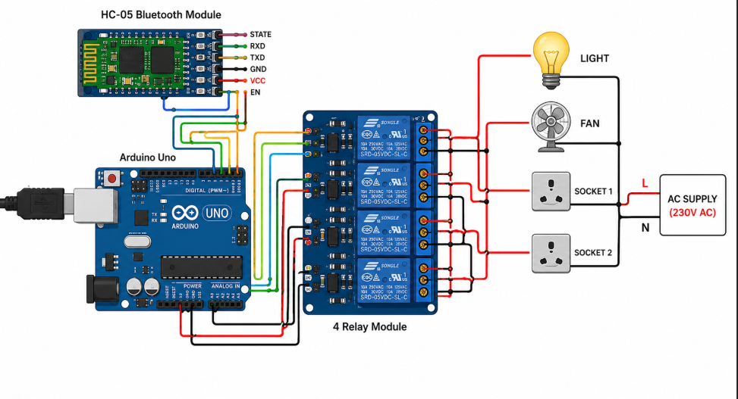
// Bluetooth Controlled Home Automation System
// Arduino UNO + HC-05 + 4 Relay Module

char data = 0;

// Relay pins
int relay1 = 2;
int relay2 = 3;
int relay3 = 4;
int relay4 = 5;

void setup()
{
Serial.begin(9600);

pinMode(relay1, OUTPUT);
pinMode(relay2, OUTPUT);
pinMode(relay3, OUTPUT);
pinMode(relay4, OUTPUT);

// Relays OFF initially
digitalWrite(relay1, HIGH);
digitalWrite(relay2, HIGH);
digitalWrite(relay3, HIGH);
digitalWrite(relay4, HIGH);
}

void loop()
{
if (Serial.available() > 0)
{
data = Serial.read();

// Device 1
if (data == 'A')
{
digitalWrite(relay1, LOW); // ON
}
else if (data == 'a')
{
digitalWrite(relay1, HIGH); // OFF
}

// Device 2
if (data == 'B')
{
digitalWrite(relay2, LOW);
}
else if (data == 'b')
{
digitalWrite(relay2, HIGH);
}

// Device 3
if (data == 'C')
{
digitalWrite(relay3, LOW);
}
else if (data == 'c')
{
digitalWrite(relay3, HIGH);
}

// Device 4
if (data == 'D')
{
digitalWrite(relay4, LOW);
}
else if (data == 'd')
{
digitalWrite(relay4, HIGH);
}
}
}

